**Americanism Promotion #2 | October 2024**

Katlyn Burke

2024-2025 National Americanism Ambassador

[auxamericanism24@gmail.com](mailto:auxamericanism24@gmail.com)

Wow! This year is in full swing, and school has been back in session for about a month now. It is the perfect time to talk with your schools and teach the kids about Flag education. While out and visiting local areas carry some patriotic materials that you can hand out and help educate others about the Flag. The U.S Flag has symbolized freedom for many years, and it is important we teach everyone about Flag education and etiquette. Properly caring and respecting the U.S. Flag plays a big part in demonstrating Americanism. For more information about Flag etiquette visit vfw.org/community/flag-etiquette. As your Auxiliary is out visiting schools and other places, look at the condition of their Flags. It may be time for their Flags to be replaced. Offer to replace the Flags and show them how to retire the U.S. Flag the correct way by having a community Flag retirement ceremony.

As a Patriotic Instructor, you have an important and crucial role in the Auxiliary. For detailed information on Auxiliary traditions, rituals and patriotic ceremonies, reference the *VFW Auxiliary Podium Edition: Bylaws and Ritual*. Patriotic items and educational materials are available for purchase through the VFW store at 1-833-VFW-VETS or online at vfwstore.org.

There are a few key things to remember as a Patriotic Instructor.

* Practice and learn our VFW Auxiliary rituals and traditions
* See that the room is in keeping with the Ritual
* Teaching members about giving the proper salute to the American Flag
* Educate members on the recitation of the Pledge of Allegiance
* Understand the Federal Flag Code

POW/MIA Recognition Day was observed on September 20. On this day, we honor those who were prisoners of war and those still missing in action. On this day, the POW/MIA flag should be displayed below and not be larger than the American Flag. What did your Auxiliary to recognize POW/MIA Recognition Day? Did your Auxiliary hold a Missing Man Table Ceremony?

Gold Star Mother’s and Family’s Day was Sunday September 29. What did your Auxiliary do to recognize the Gold Star Mothers and Families on this day?

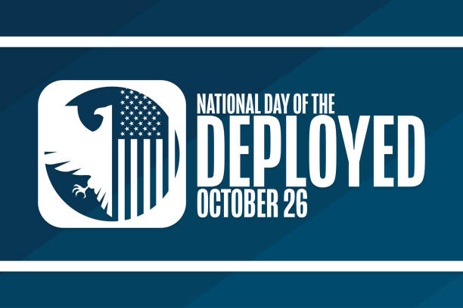A lesser-known Patriotic holiday coming up is Day of the Deployed, which is on October 26. This day honors all service members who have been deployed, are sacrificing or have sacrificed their lives to defend our country. This day also honors their families and the sacrifices they have made during the deployments for their family members to serve our country. As we recognize more common patriotic holidays and the holiday season, it’s important to recognize lesser-known holidays as well.

* U.S. Navy Birthday: October 13
* Day of the Deployed: October 26
* Election Day: November 5
* U.S. Marine Corps Birthday: November 10
* Veterans Day: November 11
* Thanksgiving: November 28
* Pearl Harbor Day: December 7
* U.S. National Guard Birthday: December 13
* U.S. Space Force Birthday: December 20

Awards, awards, awards! For the Americanism Program we have awards for Auxiliaries, Departments and Department Chairman. Awards for the Auxiliaries is the Auxiliary in each division that hosts the most outstanding activity and/or event educating their community about lesser-known patriotic holidays. The awards for the Department Americanism Chairman in each of the 10 Program Divisions for the best promotion of lesser-known patriotic holidays.

I’ve heard from almost all the Departments and have enjoyed reading what each Department does for the Americanism Program. There have been many creative ideas so far this year, especially when it comes to promoting and educating others about lesser-known holidays. I look forward to hearing more from Departments as the year goes on!